Advanced Engineering Mathematics, by Erwin Kreyszig 10th. Ed.

**Problem Set 10.5**

No. 1

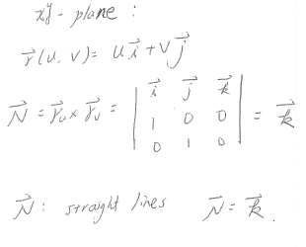

No. 2

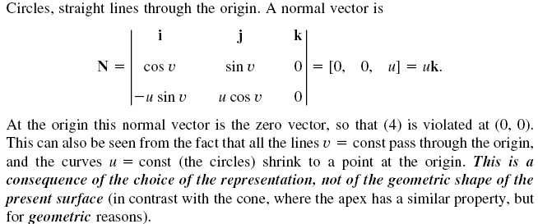

No. 3

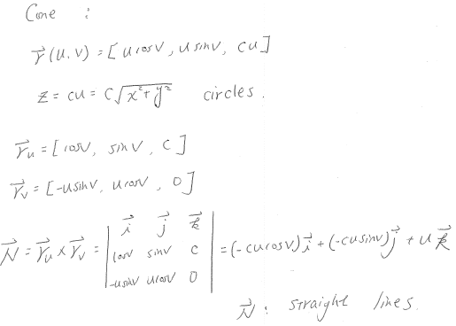

No. 4

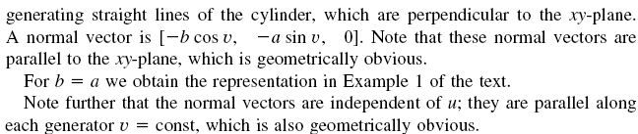

No. 5

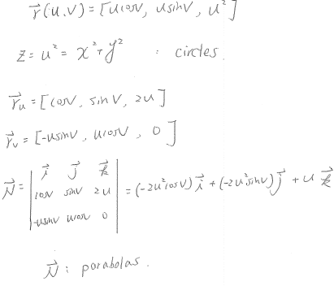

No.6

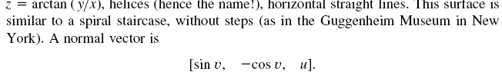

No. 7

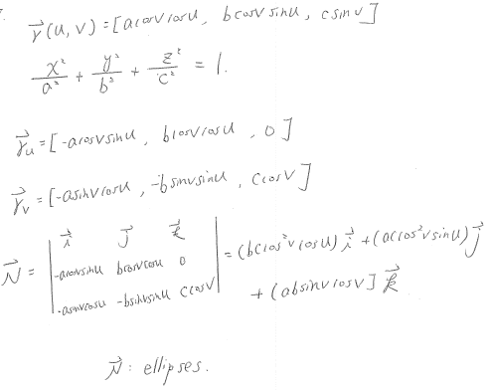

No. 8

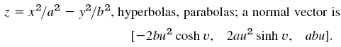

No. 9

問答或證明題，不解

No.10



No.11



No.12

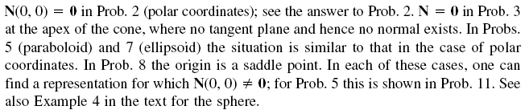

No.13

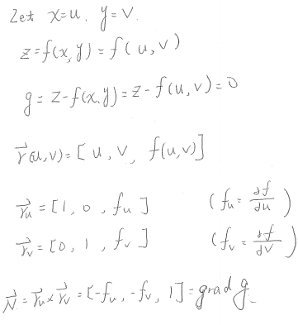

No.14

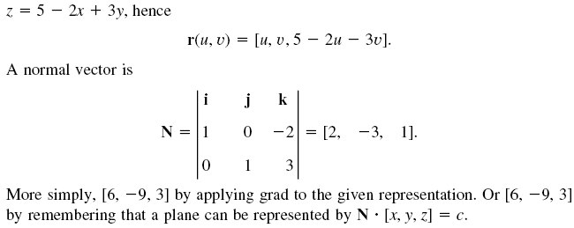

No.15

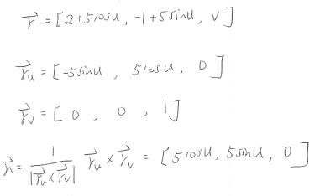

No.16

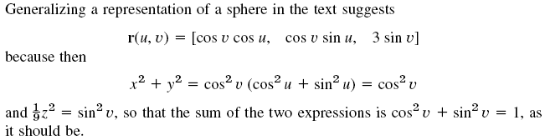

No.17



No.18

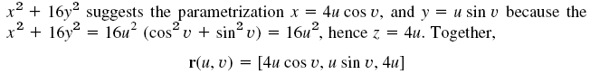

No.19

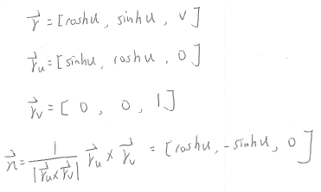

No.20

